**Experiment No. 1.3**

**Student Name: Rishav Kumar UID: 22MCC20039**

**Branch: MCA - CCD Section/Group: MCD-1/ Grp A**

**Semester: II Date of Performance: 3rd Mar 23**

**Subject Name: Advanced Internet Programming Lab Subject Code: 22CAP-686**

1. **Aim/Overview of the practical:**
2. Write a servlet to display current time and refresh at every 5 seconds.
3. Write a servlet code to forward a request to another Servlet
4. **Steps for practical:**

**A.**

* Create a new Java project in your preferred IDE.
* Create a new servlet class by right-clicking on the project folder, selecting New -> Servlet.
* Import the necessary packages: javax.servlet.*, javax.servlet.http.*, and java.io.*.
* Extend the HttpServlet class to create a servlet that handles HTTP requests.
* Override the doGet() method to handle GET requests.
* Within the doGet() method, create a PrintWriter object to send output to the client.
* Use the PrintWriter object to output an HTML page that contains a script to refresh the page every 5 seconds.
* Use the java.util.Date class to get the current time.

import java.io.IOException;

import java.io.PrintWriter;

import static java.lang.System.out;

import java.util.Date;

import javax.servlet.ServletException;

import javax.servlet.annotation.WebServlet;

import javax.servlet.http.HttpServlet;

import javax.servlet.http.HttpServletRequest;

import javax.servlet.http.HttpServletResponse;

import javax.servlet.http.HttpSession;

@WebServlet(urlPatterns = {"/NewServlet"})

public class NewServlet extends HttpServlet {

protected void processRequest(HttpServletRequest request, HttpServletResponse response)

throws ServletException, IOException {

response.setContentType("text/html;charset=UTF-8");

try (PrintWriter out = response.getWriter()) {

out.println("<!DOCTYPE html>");

out.println("<html>");

out.println("<head>");

out.println("<title>Servlet NewServlet</title>");

out.println("</head>");

out.println("<body>");

out.println("<h1>Current Time: " + new Date() + "</h1>");

out.println("<meta http-equiv=\"refresh\" content=\"5\">");

out.println("</body>");

out.println("</html>");

}

}

* Use the PrintWriter object to output the current time in the HTML page.
* Compile and deploy the servlet to your web server.

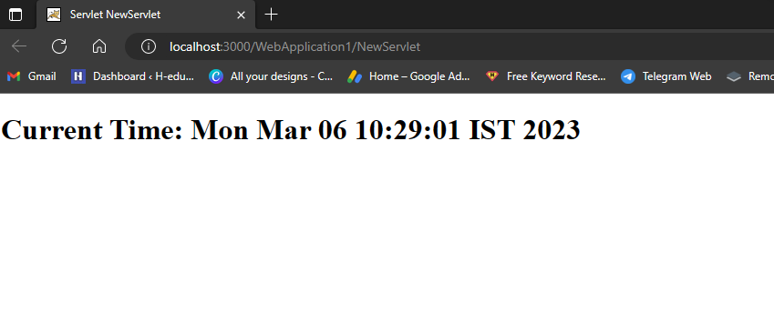

**B.**

* First, create a new Java Web project in NetBeans and name it "ForwardRequestExample". Then, follow these steps:
* **Step 1:** Create an index.html file
* Right-click on the "Web Pages" folder in the "Projects" window, then select "New" and "HTML Page" to create a new HTML file. Name the file "index.html" and add the following code:

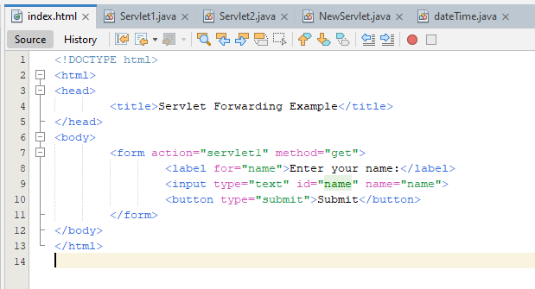

This will create a simple HTML form that sends a POST request to the "servlet1" URL.

* **Step 2:** Create a Servlet1 class
* Right-click on the "Source Packages" folder in the "Projects" window, then select "New" and "Servlet" to create a new servlet. Name the servlet "Servlet1" and add the following code:

import java.io.IOException;

import javax.servlet.ServletException;

import javax.servlet.annotation.WebServlet;

import javax.servlet.http.HttpServlet;

import javax.servlet.http.HttpServletRequest;

import javax.servlet.http.HttpServletResponse;

@WebServlet("/servlet1")

public class Servlet1 extends HttpServlet {

private static final long serialVersionUID = 1L;

@Override

protected void doGet(HttpServletRequest request, HttpServletResponse response) throws ServletException, IOException {

String name = request.getParameter("name");

request.setAttribute("name", name);

request.getRequestDispatcher("/servlet2").forward(request, response);

}

}

* This code retrieves the message from the request parameters, sets it as an attribute of the request object, and then forwards the request to the "servlet2" URL.
* **Step 3:** Create a Servlet2 class
* Right-click on the "Source Packages" folder in the "Projects" window, then select "New" and "Servlet" to create another servlet. Name the servlet "Servlet2" and add the following code:

import java.io.IOException;

import javax.servlet.ServletException;

import javax.servlet.annotation.WebServlet;

import javax.servlet.http.HttpServlet;

import javax.servlet.http.HttpServletRequest;

import javax.servlet.http.HttpServletResponse;

@WebServlet("/servlet2")

public class Servlet2 extends HttpServlet {

private static final long serialVersionUID = 1L;

@Override

protected void doGet(HttpServletRequest request, HttpServletResponse response) throws ServletException, IOException {

String name = (String) request.getAttribute("name");

response.getWriter().append("Hello, " + name + "!");

}

}

* This code retrieves the message attribute from the request object and then displays it on a simple HTML page.
* **Step 4:** Run the application
* Right-click on the "ForwardRequestExample" project in the "Projects" window, then select "Run" to start the application. This should open the index.html file in a web browser.
* Enter a message into the form and click the "Send" button. This should forward the request to Servlet1, which will set the message as an attribute of the request object and forward the request to Servlet2.

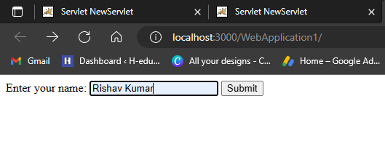

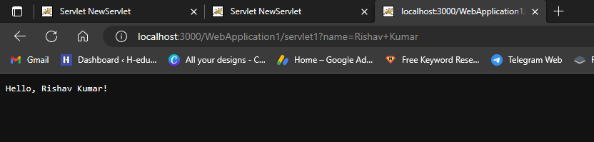

**************************************** **THE END** ***********************************************